SANTA ROSA LIBRARY ADVISORY BOARD

Sonoma County Library

Wednesday, September 27, 2023

Rincon Valley Regional Library

6959 Montecito Blvd, Santa Rosa, CA 95409

**MINUTES**

**PRESENT:** LAB Chair Pamela van Halsema, LAB members Cynthia Denenholz, Ana Diaz, Noah Harris, Robyn McManus, and Serge Zimberoff; LAB Youth members Lauren Chavez and Molly McNeill; Library Commissioner Sarah Laggos, Friends of the Library representative Joe Seymour, Library Division Manager, Public Services, Sarah Vantrease, Northwest Branch Manager Ana Dawe, Rincon Valley Branch Manager Jennifer Duran, and Roseland Branch Manager Rosalie Abbot

1. **CALL TO ORDER—6:04 PM**
2. **APPROVAL OF MINUTES OF** July 26, 2023. The minutes were approved with amendments changing “Agenda” to “Minutes” on page 1 and “Noel” to “Noah” on page 3**.**
3. **PUBLIC APPEARANCES**

*An opportunity for members of the public to address the Library Advisory Board; times are limited to 3 minutes and may be changed at the Library Advisory Board’s discretion.*

None

1. **SPECIAL ANNOUNCEMENTS & INTRODUCTION**

4.1 Welcome new LAB Members

Each person present introduced themselves and made a statement as to why the Sonoma County Library is important to them

1. **DISCUSSION ITEMS**

**5.1 Advocacy for Road Traffic and Pedestrian Safety around Santa Rosa Libraries**

Rosalie is concerned by the busy Dutton Avenue and Sebastopol Road intersection near the Roseland branch. There are virtually 5 lanes of traffic in front of the branch and fatal pedestrian accidents have occurred, including a recent one. There are lots of older people, children, teens, and bikes in the area.

The other managers discussed their branches’ traffic issues. Ana Dawe stated that the recently installed bollards at Northwest have really helped keep people from parking on sidewalks as they did in the past—even though one of these bollards has been knocked over multiple times! The NW staff would like to see a crosswalk between the Coddingtown parking lot and Library’s front door.

Jennifer Duran stated that there is now overnight security at the Rincon Valley branch so there’s no longer a problem with people sleeping overnight in cars in the parking lot. The branch has bollards because of handicapped parking marking to the sidewalk; unfortunately, on occasion people have tripped over the bollards.

Those present did not think that there is a traffic problem at the Central branch.

Ideas posed for the concern about the Roseland branch: take a photo and submit it to the City online; contact the City Manager’s Office; check with the City Traffic Department to see if a traffic study has been done or is planned.

Pam wrote a letter to Jaime Smedes, the City’s Communications Coordinator, regarding the Roseland traffic issues. Based on Ms. Smedes’ suggestion, Pam and Rosalie will reach out to Ms. Smedes to arrange a meeting with SR staff.

Pam suggested that we all might want to send a message to the City to voice our concern about the Roseland traffic issue.

**5.2 Community Survey Results**

A community survey of 891 people was completed by Godbe Research regarding the viability of the renewal of Measure Y. The survey results and a FAQ sheet were distributed to LAB members before the meeting. The results were very encouraging, with 78.8% saying they would support the renewal and 56+% saying they definitely would do so.

LAB members should take note of the services and other items set forth in the survey that the public supported strongly and remember them when out in the community talking to people about the Library. At the October Commission meeting, an agenda item will be the approval of a contract for a public education campaign. The LAB will want to participate in public education; before doing so, LAB members should review the most recent Measure Y Oversight Committee report to see and be able to tell the public exactly how the Measure Y tax money has been spent.

**5.3 Northwest Library Branch name**

Serge distributed a Neighborhood Profile of Coddingtown. He stated that the name Coddingtown is not trademarked and realtors don’t consider this area Northwest. Neighbors he spoke with and others all refer to this branch as Coddingtown, and not as Northwest.

Those present refer to this branch as either Coddingtown or Northwest. For most of the public, it appears that the branch is called “Northwest, located in the Coddingtown parking lot”. The Library does not have a naming policy for branches per Sarah V. It would be a huge paperwork effort for the Library to make this change and might not be worth the effort.

Noah suggested that we can achieve clarity for the public via communication. On behalf of the Friends, Joe offered to buy a new sign to put up inside the branch which boldly states, “Northwest Santa Rosa, Coddingtown”.

Jennifer proposes that all of the branches carry the name “Community Library”.

**5.4 Library Closures due to Air Quality**

Some branches were closed and others weren’t when the air quality was poor. Sarah L pointed out that the Library is using Purple Air for air quality measurements and that union contracts require that a branch close if the AQI inside is greater than 100.

Director Erika Thibault has relayed that the Library has 8 air scrubbers but there are 12 branch locations. (It takes 2-3 scrubbers to clean the air in some buildings.) The Library is looking to rent more air scrubbers and see if they can be turned on earlier in the AM.

Erika T. also has said that libraries may be community resilience hubs, for which there are grants. There are also state resilience grants that might be used to help improve HVAC systems. Sarah L reminded everyone that any such work must be done jointly with the cities because they--and not the Library--own the buildings.

It was opined that the public would prefer that all branches are open when the air quality is poor, but that at least there should be signs in the parking lots as well as on the doors advising customers of the closures and the reasons behind them.

Pam urged Sarah L. to represent the LAB’s position at the October Commission meeting.

**5.5 Vision and Goal Setting**

Continued to November meeting

1. **ACTION ITEMS**

6.1 **Advocacy for Road Traffic and Pedestrian Safety around Santa Rosa Libraries**

Pam and Rosalie will meet with the City of Santa Rosa representatives. Otherwise, the LAB is not going to take action at this time.

1. **REPORTS**

*Reports and updates on library governance, management, programs, services and support group activities as well as City Council matters. All items are for discussion only.*

* 1. **Youth Members’ Report**

Molly went to the Julissa Arce author talk at Central. Friends of the Library loaned out some of the author’s books, which Molly appreciated. She thinks that author talks are a good draw for teens. Molly also thinks that tall bookshelves such as those in the Healdsburg branch teen section are better for teens, who are closer to adult height.

Lauren’s mother is a librarian in Windsor and she’s learning a lot from her.

* 1. **Friends of the Santa Rosa Library Report**

Joe encouraged the managers to get any requests to the Friends before their next meeting. The Friends continue to get solid donations, including days when they receive 100 boxes of books, and the group has a good financial balance. It just gave another $25K for the Roseland project. The Friends also raised $7K at the August book sale and approved money for the Library Staff Appreciation Day.

A big book sale is coming up next week at Vets Building.

* 1. **Library Commissioners’ Report**

The Commissioners will have a retreat on October 14. The Commissioners took a tour of the Sonoma County Archives and it was great to see how well the Library stewards those materials.

Great news: the Community Foundation gave $250K to the Roseland project.

* 1. **Library Director’s Report**

The Summer Reading Program wrapped up with these statistics: 30 million minutes, 1,800 programs, and 45,000 attending these programs. The video about the teen interns working with the food program can be accessed via last month’s Commission meeting. The program is great for the teens and for the community.

The Bibliobus is getting lots of publicity and will continue going to events. The bus also makes regular stops in the community.

This fall, a Library staff team and Commissioner Laggos will be working on the mission, vision, and values statements. There will be space for LAB and community input.

* 1. **Feedback to Branch Managers’ Reports**

LAB members remarked very positively on the many different and innovative programs and activities at each of the branches.

**Northwest Branch Report**

**Submitted by Ana Dawe, Branch Manager**

The Northwest Library has continued to be a busy branch with regular visits from a local school and members of a nearby day activity center for adults. We are in back-to-school mode and getting ready for fall events.

Fun fact: Northwest creates about 250 new library accounts every month (Savannah Orangeboy).

Along with several other branches, Northwest has introduced a quiet study pod. It has become quite popular, particularly among Literacy tutors.

**From the desk of Adult Services Librarian, Philip.**

I am continuing to do monthly visits to Brookdale Paulin Creek along with Briana and the BiblioBus. We now have regular patrons, who are unable to visit the branch, who look forward to our visits. We also went to the Sonoma County Indian Health Project’s Senior Veggie Day. It was a nice opportunity to engage with Sonoma County’s American Indian community.

Community Action Partnership and JobLink have been tabling at Northwest, providing our patrons with information about job seeking skills/resources, low-cost internet, rental and utility assistance, pre-school/childcare, and family support.

We had Lotería (Mexican bingo) at Northwest, where we debuted a special library themed Lotería set designed by our very own graphics department. People of all ages participated and won prizes like potted succulents, gift cards, and candy bags.

We have some great Adult/All ages events coming up at Northwest in September, including Sugar Skulls Workshop, Crafting with Creativebug: Charcoal, and UC Master Gardeners.

Here are Briana and I at Brookdale, with Michelle Rodriguez, the Activities Coordinator for Brookdale Paulin Creek:

**From the desk of Children’s Services Librarian, Kim.**

August

I did Outreach with the Biliobus at the WIC Farmer’s Market near Coddingtown Mall and met lots of local families with babies & toddlers.

I did Outreach at the Sonoma County Indian Health Project’s “Backpack Giveaway,” and gave free Summer Reading prize books to kids and teens.

Kids “Made a Tiny Picture Book” together with Chiyoko Gueler, a Northwest patron and self-published author/illustrator of kids’ books.

September

Bilingual Preschool Storytime has started up on Friday mornings.

Colors of Spanish started Spanish Music & Movement on the 2nd Saturdays of every month.

I attended “Open House” at Helen Lehman Elementary and gave away free books to kids of all ages.

Here is a picture of the youngest reader I’ve ever met:

Read to a Dog is going strong at Northwest on Thursday afternoons.

Here are some of our PALS regulars:  Annie, Zazzle, Elvis & Beb

Santa Rosa Firefighters will do a “Firefighter Story Hour” at Northwest on Saturday, September 23!

They will bring the fire truck and read stories.

There are lots of fun Latin Heritage events coming up this month:  Chiquy Boom Dance Party, Bilingual Paint Party, and more!

😊

**From the desk of Young Adult Librarian, Melissa.**

August was a fairly quiet month for teen services.  Our Lunch at the Library program ended, and sadly we had to say goodbye to our two teen interns.  School started in mid-august, so teens, parents, and teachers were adjusting to the new school year and were not at the library as much.

September:

* The all-ages Yarn Experience program started back up again on 9/12 and takes place every Tuesday, 6:30-7:30pm. We have returning participants and some new folks as well!
* The 6th-7th-8th grade class at Village Charter visited the library on Thurs, 9/7.  They were a delight, as usual, and will be visiting about once a month throughout the rest of the school year to check out library books.
* I have started a Drop In Teen Volunteer Hour every Thursday, 4:30-5:30pm
* On 9/14 visited all four of the 7th grade English classes (about 120 students) at Piner Olivet Charter School to explain how their Student One cards work. Several students have stopped by Northwest since my class visit! 🙂
* We will be hosting the three-part Scholarship info program for teens:
  + <https://events.sonomalibrary.org/event/paying-college-scholarships-workshop-1?language=en>
  + <https://events.sonomalibrary.org/event/paying-college-scholarships-workshop-2?language=en>
  + <https://events.sonomalibrary.org/event/paying-college-scholarships-workshop-3?language=en>
* We will be hosting first Northwest Teen Council meeting:
  + <https://events.sonomalibrary.org/event/northwest-teen-council-2?language=en>

**Rincon Valley Regional Library**

**Submitted by Jennifer Duran, Branch Manager**

Meher, our Library Associate was out taking a walk during one of her breaks just as school let out at the Rincon Valley Middle school. She passed and greeted a student who is a regular after-school library user. He stopped in his tracks and asked in a panicked voice, "Wait! Is the library closed?!" Meher was very amused and replied that no, the library was open but that "they let me out sometimes!" 😉

It is heartening and true validation to feel how much our community, young and older, needs, and appreciates us!

The Mostly Modern Quilt Guild has their quilts hanging in the reading room. The exhibit is up through Tuesday, October 17. Still plenty of time to plan a visit to see their beautiful quilts! This is our third quilt show of the year! The Mostly Modern Quilt Guild held a small public reception one August evening in our meeting room where members were able to socialize in person after years of Zoom meetings. The Santa Rosa Quilt Guild has been volunteering their time and materials to hold beginning sewing and beginning quilting classes that are very popular. Participants in these classes have been making amazing projects such as tote bags, pillowcases, potholders and pincushions to name a few!

Our new BiblioBox Locker service is live! The service offers 24/7 pickup option for library holds. We will hold your library material for up to 72 hours inside the locker. To utilize this pickup method, you must select “Rincon Valley BiblioBox” as your Pickup Library when placing a hold for a library item. Of course, if you don’t mind waiting until the library is open, you always have the option to select “Rincon Valley Regional Library” and we will continue to place your

hold inside the building on our hold shelf.

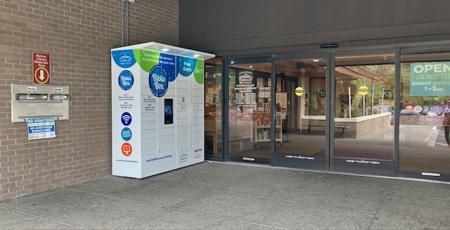 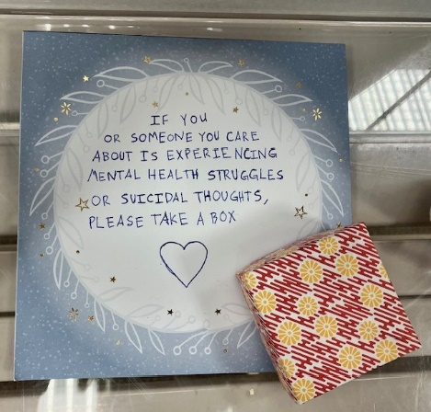

Checkout NEW BiblioBox Locker!

Sonoma County Library is celebrating Latin American Roots, September 15-October 15. At Rincon Valley Library, we have several book and media displays and book lists ready for our patrons to browse and enjoy. September is also National Suicide Prevention Month and staff have created a small display of books and gift origami boxes on a small table inside our library. The origami box and its contents is an inspired team effort by staff Sasha, Meher, and Jennifer. Inside the box is a tiny origami crane and heart-shaped bookmark along with a scroll with more information about seeking help. After September, we are going to keep providing these boxes year-round in our community information area.

Sonoma County Library's BiblioBus has established regular community stops within Rincon Valley's service area. On the first Thursday and Fridays of each month, Adult Services Librarian Julie accompanies the bus to the following senior housing centers:  Oakmont Gardens, PEP Housing's Vigil Light Apartments, PEP Housing's Acacia Lane Apartments, and PEP Hosing's Linda Tunis Apartments.

The residents are always excited to see the BiblioBus at their community.  Many no longer drive, and this is their only contact with Sonoma County Library.  The bus is packed with the latest, popular books, DVD's and audiobooks which are available for checkout.  If folks don't have a library card- no problem!  We can issue one right away. Julie and BiblioBus Librarian Briana are also available to answer any questions and help these patrons on getting access to all the library's eResources.

Nicole our Teen Services Librarian is very busy visiting schools this September. She will be visiting an 11th grade Sociology class from Maria Carrillo High School presenting a slide show about one of Sonoma County Library’s many online eResources, [SIRS Discoverer.](https://sonomalibrary.org/elibrary/a-z/sirs-discoverer)  Nicole is deeply involved in creating content for Sonoma County Library’s eResource [Student Success Tutorial Series](https://sonomalibrary.org/elibrary/student-success-tutorials). It is great fun for her to get invited into the classroom to share all the cool databases available to all our students with the use of their Student OneCard. She also has class visits scheduled at Rincon Valley Middle School and a teacher presentation at Maria Carrillo High School. Early in October she will be joining the BiblioBus for a stop at Spring Lake Middle School, and in mid-October presenting to four classes at Montgomery High School.

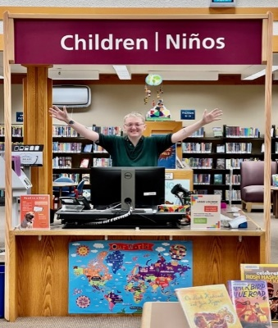

Meher conceptualized a new sign for the children’s services desk. We ran the idea past our Graphics Team and they made it come alive! Sending a huge thank you to both Graphics and Facilities for attaching the new sign to our children’s services desk.

Fall programming has started, which means storytime is back on Friday mornings and on some Saturday mornings. Amanda is meeting new families who are not able to plan storytime in to their Monday-Friday work and school week. To help, we have several more Saturday storytimes planned for October and November to help make Family Storytime a weekend event for some families.

Our branch has received $4500 in funding from the David and Lucile Packard Foundation to implement a Stay & Play program series in spring 2024. This early literacy program will strengthen our commitment to provide information and community resources to informal care providers like grandparents, nannies, and neighbors who provide weekly care for young children under the age of 5 whose parents may otherwise be working or attending school. A majority of our Friday Family Storytime participants are not young children accompanied by a parent, but rather accompanied by a grandparents or a nanny. Amanda and Jennifer will attend a series of online professional development courses this fall along with meeting virtually with other Stay & Play libraries in California. Rohnert Park-Cotati Library is also a Stay & Play funding recipient.

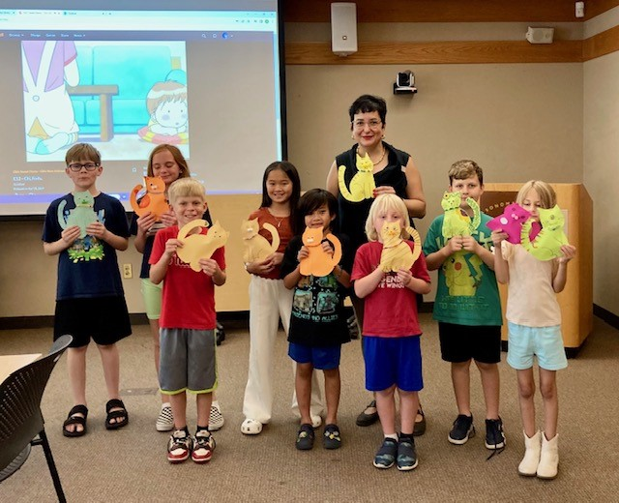 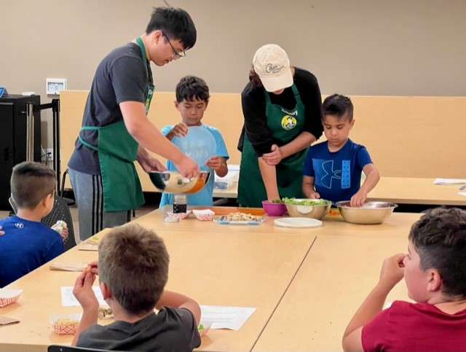

We have many other exciting programs coming this fall for children and families. Biweekly on Wednesday in September, October and November, we are hosting Kids Can Cook Healthy Foods, cooking/nutrition classes taught by teens through the Ceres Community Project. Another exciting program series is Spanish Movement and Music which will begin on 9/27 and reoccur every fourth Wednesday morning. Early in September we had our first Lego Lounge meeting, and every third Wednesday of each month Amanda will be hosting Manga Book Club. This October they will be starting up a biweekly STEAM/Coding program for children with staff volunteering from Keysight Technologies.  Another continuing collaboration will occur with the Santa Rosa Mother’s Club. They and Amanda collaborated on a Saturday storytime this past summer. It proved so successful that it just makes sense to collaborate again. Amanda presents the storytime and the Mother’s Club plans for and sets up the craft to follow.

**Roseland Regional Library**

**Submitted by Rosalie Abbott, Branch Manager**

**Staffing**

This month, Veronica, our bilingual Shelver who we has been working with us for the previous year, has moved on to begin her studies in STEM at UC Davis. We are excited to announce that we have added a new bilingual Shelver to our team. Esther started her work with SCL at the Sebastopol Regional Library, however she is from Roseland and is excited about her transfer to our unique branch and to be working within the community here.

Current Staffing:

Rosalie - Branch Manager

Roxanna -Bilingual Adult Librarian

Serena - Bilingual Childrens Librarian

Emily - Teen Services Librarian

Marlene - Bilingual Senior Library Associate

Jose - Bilingual Library Specialist

Yisel - Bilingual Library Specialist

Ale - Bilingual Library Specialist, 20hrs

Esther - Bilingual Shelver, 15hrs

**Collection**

Our dedicated Reference team has been actively curating a collection tailored to meet the diverse needs of our library patrons. This endeavor encompasses meticulous evaluation, curation, research, and acquisition of new materials. The complexity of this task is amplified by our focused efforts on amassing a comprehensive assortment of Spanish-language materials, necessitating proficiency in the language, adept review analysis, and a deep understanding of resource availability and procurement. We deeply appreciate the unwavering support provided by the SCL Collections Team, which has been instrumental in meeting our branch's requirements.

Generous funding from Santa Rosa Friends group has paved the way for an exciting expansion in our nonfiction collections for children as well as new books for adults. We anticipate improvements of not only a modernized collection but also a thoughtful curation of materials aligned with community interests and preferences, ensuring a captivating and enriching library experience.

Our collection is also particularly health in terms of DEI (Diversity, Equity, and Inclusion) statistics. The Roseland Library has the highest DEI levels out of any location in our system—except, we have been narrowly outpaced by the infamous BibioBus! See a snapshot of our DEI stats below.

**Programming:** All of our Sonoma County Library branches are Celebrating Latin American Roots this month with book lists, displays, passive programs and events! See below for a few of our highlights.

**School Visits:** Our Teen Librarian’s schedule has been full of visits to classes at the middle and high schools. She is sharing about library resources, eResources, programs, volunteer opportunities, and more! Our Children’s Librarian has already hosted many, many class visits—usually held before our open hours. Most of the classes walk to the library and are so excited to hear book talks, songs, participating in some dancing, as well as searching for the perfect books to check out on their Student One Cards. We had over 100 TK & Kindergarteners attend the Firefighter Storytime in our tiny children’s area!

**Visiting Author Event:**

On September 23rd, bestselling author Julissa Arce talked about her new book "You Sound Like a White Girl" which explores timely topics such as immigration and assimilation. She spoke at two events, one at Central Santa Rosa Library, as well as at Andy’s Unity Park.

Julissa Arce, a renowned author, speaker, and social justice advocate, challenges the notion that assimilation leads to belonging in her latest book, "You Sound Like a White Girl." Instead, she boldly asserts that true belonging stems from celebrating one's unique identity, history, and culture, rejecting the white gaze. Julissa's work unveils hidden history and demonstrates the path to creating an America where diversity is cherished, heritage is embraced, and belonging is inclusive.

Recognized as one of People en Español's 25 Most Powerful Women in 2017 and honored as the 2019 Woman of the Year by the City of Los Angeles, Julissa is a prominent voice in the fight for social justice, immigrant rights, and education equality. Her contributions extend to publications such as The New York Times, TIME, Buzzfeed News, Crooked Media, and CNBC. Additionally, she co-hosts Crooked Conversations and provides political commentary on various TV networks, including NBC News, Bloomberg TV, CNN, and MSNBC.

**Additional highlights:**

Hora del cuento con los bomberos de la Ciudad de Santa Rosa / Firefighter Story Hour (over 100 children in attendance!)

Clases de Ciudadanía en Español Gratis / Free Citizenship Classes

Roseland Club de manga para jóvenes / Roseland Teen Manga Club

¡Viajemos a Sugarloaf!: Senderos Naturales / Field Trip to Sugarloaf State Park

Club de Cultura / Lean to Play Marbles: Aprende a jugar canicas en este programa en español. Este es un evento inclusivo para todas las edades y habilidades.

Alfileres y Agujas Club de Coser / Pins & Needles Sewing Club

Pulseras de la amistad / Create Teen! ¡Ven y haz una manualidad en la Biblioteca Regional de Roseland todos los viernes de 4:30-5:30pm! Cada semana habrá una manualidad diferente para los adolescentes, así que traigan sus mentes creativas. Se proporcionarán bocaditos y todos los materiales.

¡Tenemos muchas cuentas y cuerdas de colores para que hagas pulseras de la amistad esta semana!

Jueves de Juegos / Spanish Family Fun: ¡Únete con nosotros cada jueves para jugar en familia! Este programa sin cita ofrecerá nuevos juegos, materiales de arte, y desafíos para alentar a los niños a explorar y descubrir. Este es un evento inclusivo.

* 1. **City Council Liaison Report—**None

1. **ADVISORY BOARD INFORMATION ITEMS**

*An opportunity for Members to present brief, factual information about their library, respond to public comments, place items on the next agenda, or request information from the Library Commissioners, Director or Branch Managers.*

The LAB members detailed their many and varied interactions with and for the Library.

1. **FOLLOW-UP & NEXT STEPS**

* **Rosalie and Pam will follow up regarding the traffic issue and report back.**

1. **ADJOURNMENT: The meeting adjourned at approximately 7:40 PM**